Project

On



**“Premier League Football”**

**Database Management System**

**Prepared by**

**GROUP NO: 4**

|  |  |
| --- | --- |
| Name | ID |
| Talukder, Jamilush Siam | 14-25484-1 |
| Tasnim, Jereen | 14-26397-1 |
| Wasiullah, MD Arafat | 14-26022-1 |

**Submitted to**

**MD. EZAZUL ISLAM**

**Lecturer,**

**American International University - Bangladesh**

**Office: House# 55/B, Road# 21, Kemal Ataturk Avenue, Banani, Dhaka-1213**

**Subject: Introduction to Database**

**Section: H**

**INDEX**

|  |  |  |
| --- | --- | --- |
| Chapter  No. | Chapter Name | Page  No. |
| 1 | Proposal of the System | 3 |
| 2 | Introduction | 4 |
| 3 | De-Normalized Schema of Database | 5 |
| 4 | Normalization up-to 3NF | 5 |
| 5 | Entity Relationship Diagram of the system | 7 |
| 6 | Table Creation and Sample Data Insertion | 8 |
| 7 | User Questionnaire | 20 |
| 8 | SQL Query Based on User Questionnaire | 21 |
| 9 | Relational Algebra | 25 |
| 10 | Conclusion | 26 |

# Chapter 01

# Proposal of the System

**Situation:** Soccer enthusiasts who always love to keep themselves updated find it difficult to search the information needed on a daily basis. The track record of every player and team are found on different websites thus it is almost impossible to check all the websites and collect all the data when needed. Moreover it will really time consuming if someone wants to find out specific information regarding a specific player.

**Proposed Solution:** The laborious work of searching the record of players/teams can be eradicated by creating well defined database. It will allow a user to find any data regarding soccer in seconds hence make life easier.

**Steps Involved:**

1. Creating an E-R diagram.
2. Collecting all data regarding soccer
3. Inserting all data in Database system
4. Removing anomalies up-to 3NF

**Benefits:**

1. Anyone can find desired information about players/team within few seconds.
2. All information in a single database system.

**Potential Obstacles:**

1. Only the information that is included in database system can be accessed and searched.
2. The created database system might not satisfy all the users’ needs.
3. A group of people is needed to update the database on a daily basis regarding the change in soccer.

# Chapter 02

# Introduction

Our proposed project is ‘Premier League Soccer Database’. It contains almost all information of soccer teams/players and is made for the soccer enthusiasts.

**Detailed Features:**

1. Key information of soccer players.
2. Goal Scored / Goal Assists / Goal Conceived of each teams.
3. Making point table and ranking by it.
4. Details information of coaches and owners.
5. Linking sponsor information in teams table.
6. Selecting top teams in a league.

**Users:**

We are expecting a big part of the users will be soccer lover who are hungry for updated information regularly. But our database system will also be helpful for the soccer news reporters.

# Chapter 03

# De-Normalized Schema of Database

Our database contains the information of players, teams, coaches, sponsors. One team can only have one coach and many sponsor. One can coach can only be titled to only one team. One sponsor can give sponsorship to only one team.

A de-normalized schema of our system may look like this:

Players Team, Goal Scored, Assist, Coach, Salary, Position, DOB, Location

Teams Players, Goal Scored, Assists, Goal Conceived, Stadium, Coach, Sponsors, Points

Owner Team

Stadium Location, Capacity

# Chapter 04

# Normalization up-to 3NF

We normalized our database system up-to 3NF.

**1st Normalization Form:**

A player can play in different positions. By creating a table for positions we have eradicated the multi-valued attributes hence we removed the update anomaly. Before we had to update several tuples to update a player who has more than one positions but now we have to update only one tuple to define the positions of players.

**2nd and 3rd Normalization Form:**

The points of a team depends on the Games won and Games drawn. It was not possible to insert a team’s point until the games won and drawn were counted. By removing the functional dependency we solved the insertion anomaly.

Every team has stadiums, sponsors. In de-normalized form if we had deleted one team name then the information of stadiums and sponsors would get deleted also. By normalizing to 3NF we have also fixed the deletion anomaly. Now even if we delete the name of team, the information of stadium, sponsors of that team will be preserved.

# Chapter 05

# Entity Relationship Diagram of the System

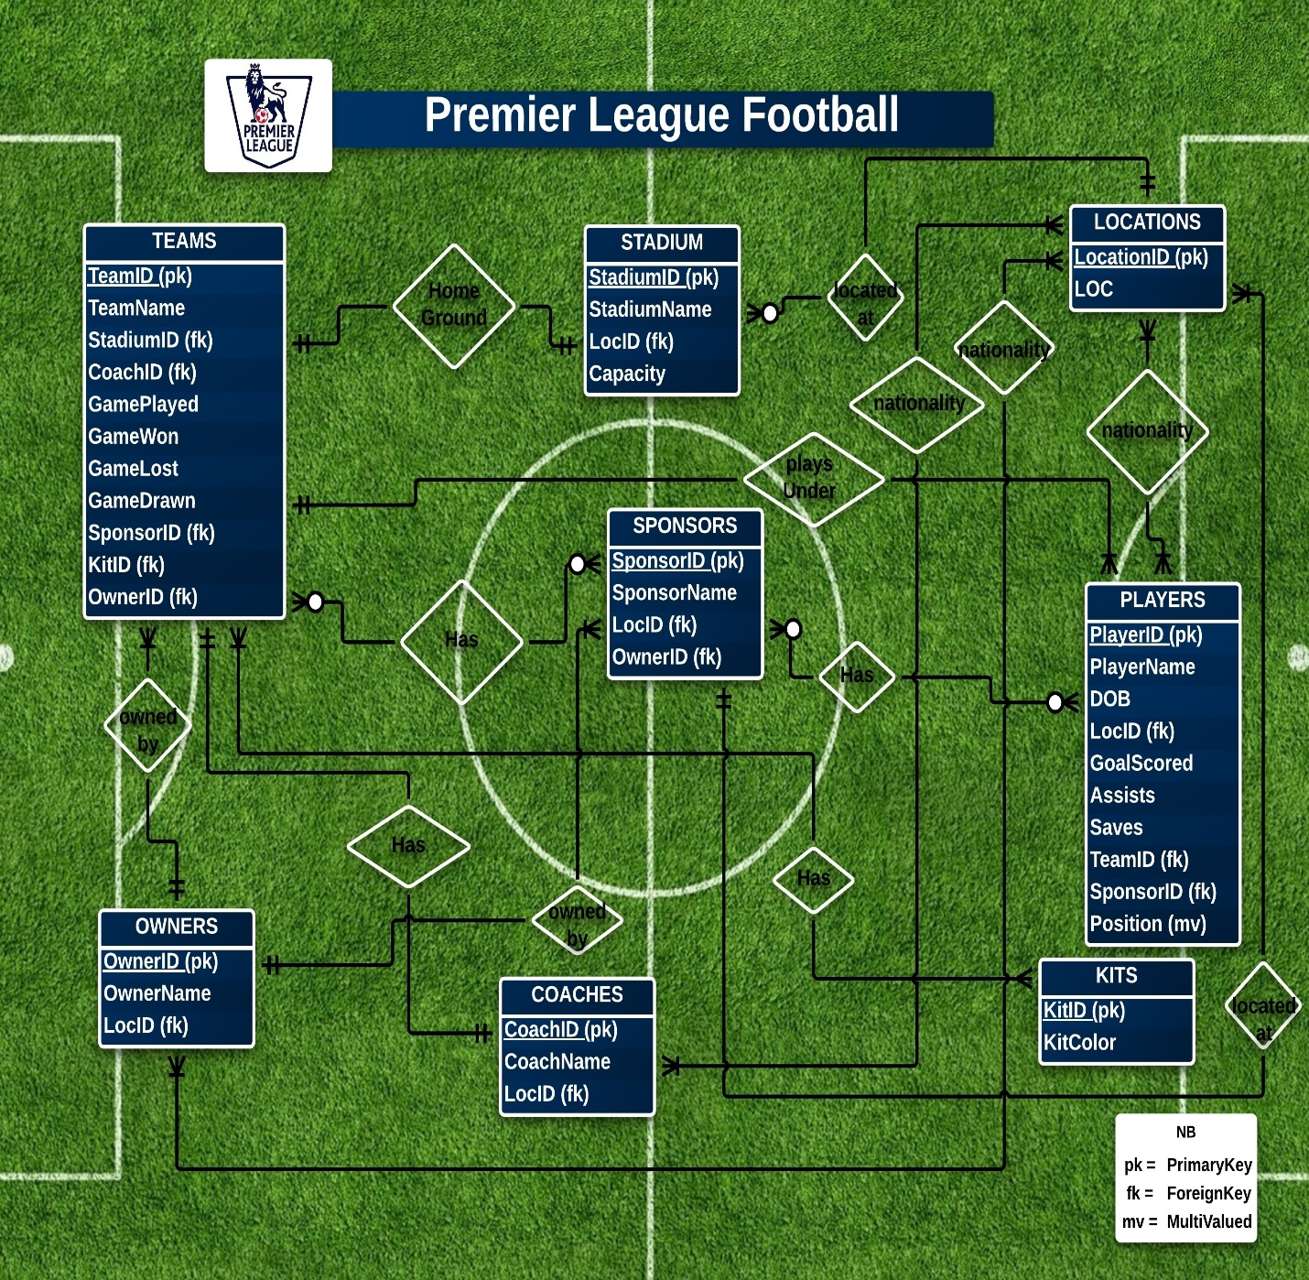

# Chapter 06

# Table Creation and Sample Data Insertion

**SQL commands for Table Creation:**

LOCATIONS table:

*CREATE TABLE LOCATIONS (*

*LOCID NUMBER (2),*

*CONSTRAINT LOCATIONS_LOCID_PK PRIMARY KEY(LOCID),*

*LOC VARCHAR2 (12)*

*)*

KITS table:

CREATE TABLE KITS(

*KITID NUMBER (2),*

*CONSTRAINT KITS_KITID_PK PRIMARY KEY(KITID),*

*KITCOLOR VARCHAR2 (12)*

*)*

STADIUM table:

*CREATE TABLE STADIUM(*

*STADIUMID NUMBER (2),*

*CONSTRAINT STADIUM_STADIUMID_PK PRIMARY KEY(STADIUMID),*

*STADIUMNAME VARCHAR2 (30),*

LOCID NUMBER (2),

*CONSTRAINT STADIUM_LOCID_FK FOREIGN KEY (LOCID)*

*REFERENCES LOCATIONS (LOCID),*

*CAPACITY NUMBER (15)*

*)*

OWNERS table:

*CREATE TABLE OWNERS(*

*OWNERID NUMBER (2),*

*CONSTRAINT OWNERS_OWNERID_PK PRIMARY KEY(OWNERID),*

*OWNERNAME VARCHAR2 (15),*

*LOCID NUMBER (2),*

*CONSTRAINT OWNERS_LOCID_FK FOREIGN KEY (LOCID)*

*REFERENCES LOCATIONS (LOCID)*

*)*

COACHES table:

*CREATE TABLE COACHES(*

*COACHID NUMBER (2),*

*CONSTRAINT COACHES_COACHID_PK PRIMARY KEY(COACHID),*

*COACHNAME VARCHAR2 (15),*

*LOCID NUMBER (2),*

*CONSTRAINT COACHES_LOCID_FK FOREIGN KEY (LOCID)*

*REFERENCES LOCATIONS (LOCID)*

)

SPONSORS table:

*CREATE TABLE SPONSORS(*

*SPONSORID NUMBER (2),*

*CONSTRAINT SPONSORS_SPONSORID_PK PRIMARY KEY(SPONSORID),*

*SPONSORNAME VARCHAR2 (15),*

*LOCID NUMBER (2),*

*CONSTRAINT SPONSORS_LOCID_FK FOREIGN KEY (LOCID)*

*REFERENCES LOCATIONS (LOCID),*

*OWNERID NUMBER(2),*

*CONSTRAINT SPONSORS_OWNERID_FK FOREIGN KEY (OWNERID)*

*REFERENCES OWNERS (OWNERID)*

*)*

TEAMS table:

*CREATE TABLE TEAMS(*

*TEAMID NUMBER (2),*

*CONSTRAINT TEAMS_TEAMID_PK PRIMARY KEY(TEAMID),*

*TEAMNAME VARCHAR2 (15),*

*STADIUMID NUMBER (2),*

*CONSTRAINT TEAMS_STADIUMID_FK FOREIGN KEY (STADIUMID)*

*REFERENCES STADIUM (STADIUMID),*

*COACHID NUMBER (2),*

*CONSTRAINT TEAMS_COACHID_FK FOREIGN KEY (COACHID)*

*REFERENCES COACHES (COACHID),*

*GAMEPLAYED NUMBER (3),*

*GAMEWON NUMBER (3),*

*GAMELOST NUMBER (3),*

*GAMEDRAWN NUMBER (3),*

*SPONSORID NUMBER(2),*

*CONSTRAINT TEAMS_SPONSORID_FK FOREIGN KEY (SPONSORID)*

*REFERENCES SPONSORS (SPONSORID),*

*KITID NUMBER(2),*

*CONSTRAINT TEAMS_KITID_FK FOREIGN KEY (KITID)*

*REFERENCES KITS (KITID),*

*OWNERID NUMBER(2),*

*CONSTRAINT TEAMS_OWNERID_FK FOREIGN KEY (OWNERID)*

*REFERENCES OWNERS (OWNERID)*

*)*

PLAYERS table:

*CREATE TABLE PLAYERS(*

*PLAYERID NUMBER (2),*

*CONSTRAINT PLAYERS_PLAYERID_PK PRIMARY KEY(PLAYERID),*

*PLAYERNAME VARCHAR2 (12),*

*DOB DATE,*

*LOCID NUMBER (2),*

*CONSTRAINT PLAYERS_LOCID_FK FOREIGN KEY (LOCID)*

*REFERENCES LOCATIONS (LOCID),*

*GOALSCORED NUMBER (3),*

*ASSISTS NUMBER (3),*

*SAVES NUMBER (3),*

*TEAMID NUMBER(2),*

*CONSTRAINT PLAYERS_TEAMID_FK FOREIGN KEY (TEAMID)*

*REFERENCES TEAMS (TEAMID),*

*SPONSORID NUMBER(2),*

*CONSTRAINT PLAYERS_SPONSORID_FK FOREIGN KEY (SPONSORID)*

*REFERENCES SPONSORS (SPONSORID)*

*)*

POSITIONS table:

*CREATE TABLE POSITIONS(*

*PLAYERID NUMBER(2),*

*CONSTRAINT POSITIONS_PLAYERID_FK FOREIGN KEY (PLAYERID)*

*REFERENCES PLAYERS (PLAYERID),*

*POS VARCHAR2 (20)*

*)*

**SQL commands for Sample Data Insertion:**

LOCATIONS table:

*INSERT INTO LOCATIONS*

*VALUES (1 ,'LONDON');*

*INSERT INTO LOCATIONS*

*VALUES (2 ,'MANCHESTER');*

*INSERT INTO LOCATIONS*

*VALUES (3 ,'LIVERPOOL');*

*INSERT INTO LOCATIONS*

*VALUES (4 ,'BERLIN');*

*INSERT INTO LOCATIONS*

*VALUES (5 ,'TOKYO');*

*INSERT INTO LOCATIONS*

*VALUES (6 ,'DUBAI');*

KITS table:

*INSERT INTO KITS*

*VALUES (1 ,'BLUE');*

*INSERT INTO KITS*

*VALUES (2 ,'RED');*

*INSERT INTO KITS*

*VALUES (3 ,'WHITE');*

*INSERT INTO KITS*

*VALUES (4 ,'YELLOW');*

STADIUM table:

*INSERT INTO STADIUM*

*VALUES (1 ,'STAMFORD BRIDGE', 1, 80000);*

*INSERT INTO STADIUM*

*VALUES (2 ,'EMIRATES STADIUM', 1, 90000);*

*INSERT INTO STADIUM*

*VALUES (3 ,'OLD TRAFORD STADIUM', 2, 75000);*

*INSERT INTO STADIUM*

*VALUES (4 ,'ETIHAD STADIUM', 2, 100000);*

*INSERT INTO STADIUM*

*VALUES (5 ,'ANFIELD STADIUM', 3, 97500);*

*INSERT INTO STADIUM*

*VALUES (6 ,'WHITE HART-LANE', 1, 50000);*

*INSERT INTO STADIUM*

*VALUES (7 ,'KC STADIUM', 2, 47000);*

*INSERT INTO STADIUM*

*VALUES (8,'GOODISON PARK', 3, 49000);*

OWNERS table:

*INSERT INTO OWNERS*

*VALUES (1 ,'ROMAN', 1);*

*INSERT INTO OWNERS*

*VALUES (2 ,'AMIR', 6);*

*INSERT INTO OWNERS*

*VALUES (3 ,'CHE LOE', 5);*

*INSERT INTO OWNERS*

*VALUES (4,'ABRAHAM', 3);*

*INSERT INTO OWNERS*

*VALUES (5 ,'SIR RICHARD', 2);*

*INSERT INTO OWNERS*

*VALUES (6 ,'YOKOSHAMA', 5);*

COACHES table:

*INSERT INTO COACHES*

*VALUES (1 ,'JORAH', 2);*

*INSERT INTO COACHES*

*VALUES (2 ,'CERCIE', 4);*

*INSERT INTO COACHES*

*VALUES (3 ,'VANGAAL', 1);*

*INSERT INTO COACHES*

*VALUES (4,'MORINHO', 6);*

*INSERT INTO COACHES*

*VALUES (5 ,'BENETIZ', 1);*

*INSERT INTO COACHES*

*VALUES (6 ,'GOMEZ', 2);*

*INSERT INTO COACHES*

*VALUES (7 ,'JAIME', 3);*

*INSERT INTO COACHES*

*VALUES (8 ,'WENGER', 5);*

SPONSORS table:

*INSERT INTO SPONSORS*

*VALUES (1 ,'NIKE', 2, 1);*

*INSERT INTO SPONSORS*

*VALUES (2 ,'ADDIDAS', 2, 4);*

*INSERT INTO SPONSORS*

*VALUES (3 ,'PUMA', 3, 2);*

*INSERT INTO SPONSORS*

*VALUES (4 ,'REEBOK', 4, 3);*

*INSERT INTO SPONSORS*

*VALUES (5 ,'SAMSUNG', 1, 4);*

*INSERT INTO SPONSORS*

*VALUES (6 ,'FLYEMIRATES', 6, 6);*

TEAMS table:

*INSERT INTO TEAMS*

*VALUES (1 ,'ARSENAL', 2, 1, 12, 6, 2, 4, 2, 2, 2);*

*INSERT INTO TEAMS*

*VALUES (2 ,'CHELSEA', 1, 6, 13, 7, 3, 3, 4, 1, 4);*

*INSERT INTO TEAMS*

*VALUES (3 ,'MAN UTD', 3, 7, 10, 5, 2, 3, 6, 4, 3);*

*INSERT INTO TEAMS*

*VALUES (4 ,'MAN CITY', 4, 8, 11, 9, 2, 0, 3, 3, 2);*

*INSERT INTO TEAMS*

*VALUES (5 ,'LIVERPOOL', 5, 5, 9, 4, 3, 2, 1, 1, 1);*

*INSERT INTO TEAMS*

*VALUES (6 ,'TOTENHUM', 6, 3, 10, 3, 5, 2, 2, 2, 3);*

*INSERT INTO TEAMS*

*VALUES (7 ,'HULL CITY', 7, 4, 8, 4, 4, 0, 1, 3, 5);*

*INSERT INTO TEAMS*

*VALUES (8 ,'EVERTON', 8, 2, 6, 2, 1, 3, 4,4, 6);*

PLAYERS table:

*INSERT INTO PLAYERS*

*VALUES (1, 'MICHEAL', '01-JAN-84',1, 12, 2, NULL, 7, 1);*

*INSERT INTO PLAYERS*

*VALUES (2, 'ROBINAL', '02-JUL-81',6, 9, 2, NULL, 7, 2);*

*INSERT INTO PLAYERS*

*VALUES (3, 'KING', '11-AUG-87',1, NULL, NULL,14, 8, 3);*

*INSERT INTO PLAYERS*

*VALUES (4, 'CECH', '21-FEB-85',5, NULL, NULL, 15,3, 2);*

*INSERT INTO PLAYERS*

*VALUES (5, 'LAMPARD', '22-SEP-82',2, 8, 12, NULL, 4, 4);*

*INSERT INTO PLAYERS*

*VALUES (6, 'DROGBA', '30-OCT-92',2, 21, 4, NULL, 6, 5);*

*INSERT INTO PLAYERS*

*VALUES (7, 'OZIL', '21-FEB-91',4, 7, 20, NULL,5, 3);*

*INSERT INTO PLAYERS*

*VALUES (8, 'SANCHEZ', '24-MAR-90',3, 22, 10, NULL, 3,2);*

*INSERT INTO PLAYERS*

*VALUES (9, 'ROONEY', '03-APR-87',1, 25, 8, NULL, 8, 5);*

*INSERT INTO PLAYERS*

*VALUES (10, 'SILVA', '04-NOV-93',3, 12, 18, NULL,5, 1);*

*INSERT INTO PLAYERS*

*VALUES (11, 'LUCAS', '09-MAY-95',4, 13, 9, NULL, 2, 4);*

*INSERT INTO PLAYERS*

*VALUES (12, 'KNEAN', '10-JUN-89',2, 19, 10, NULL, 1, 6);*

POSITIONS table:

*INSERT INTO POSITIONS*

*VALUES( 1, 'STRIKER');*

*INSERT INTO POSITIONS*

*VALUES( 2, 'DEFENDER');*

*INSERT INTO POSITIONS*

*VALUES( 3, 'DEFENDER');*

*INSERT INTO POSITIONS*

*VALUES( 4, 'GOAL-KEEPER');*

*INSERT INTO POSITIONS*

*VALUES( 5, 'MID-FIELDER');*

*INSERT INTO POSITIONS*

*VALUES( 6, 'STRIKER');*

*INSERT INTO POSITIONS*

*VALUES( 7, 'MID-FIELDER');*

*INSERT INTO POSITIONS*

*VALUES( 8, 'STRIKER');*

*INSERT INTO POSITIONS*

*VALUES( 9, 'STRIKER');*

*INSERT INTO POSITIONS*

*VALUES( 10, 'MID-FIELDER');*

*INSERT INTO POSITIONS*

*VALUES( 11, 'STRIKER');*

*INSERT INTO POSITIONS*

*VALUES( 12, 'DEFENDER');*

*INSERT INTO POSITIONS*

*VALUES( 8, 'MID-FIELDER');*

*INSERT INTO POSITIONS*

*VALUES( 1, 'MID-FIELDER');*

*INSERT INTO POSITIONS*

*VALUES( 9, 'MID-FIELDER');*

# Chapter 07

# User Questionnaire

Using this data base system many user from around the world can get answer to their desired question about the league. Also, as the league progresses, the data in this database will also be updated. Below are some example of sample questionnaire:

**Sample Questions:**

1. Find the top scorer of each team.
2. Who are the top five goal scorers?
3. Who are the top five goal assists?
4. Show a report of current league standings.
5. How many players are more than 30 years old as of 09 Aug 2015?
6. Find the players who plays under coach “WENGER”.
7. A player named “KING” now has a new position as “STRIKER”
8. Count position wise players.
9. The home ground of team “ARSENAL” has been upgraded. Now the capacity is 120000.
10. Team “CHELSEA” has won 2 more matches.
11. The color of jersey of team “LIVERPOOL” has been changed to “YELLOW”.
12. Which is the current top ranking team?
13. Find the player names who score more than 20 goals.
14. Find the stadium names whose capacity is more than 90000. Also find the location of those stadiums.
15. Find the date of birth and goals scored of those players whose id is 2 or 6 or 8.
16. Find the sponsor name whose location is berlin.
17. Find the player names whose sponsor is addidas.
18. Find the names of any player whose position is STRIKER.
19. Show the average game won under the owner named ‘CHE LOE’.
20. Find the minimum goals scorer whose date of birth is before 1990

# Chapter 08

# SQL Query Based on User Questionnaire

Below are the SQL query for the sample questions of the chapter 07.

1.

*select players.playername, teams.teamname, MAX(players.GOALSCORED)*

*from players, teams*

*where players.teamid = teams.teamid*

*Group by teams.teamname,players.playername*

2.

*select playername, GOALSCORED*

*from (*

*select playername, GOALSCORED*

*from players*

*order by NVL(GOALSCORED,0) desc*

*)*

*WHERE ROWNUM <= 5*

3.

*select playername, assists*

*from (*

*select playername, assists*

*from players*

*order by NVL(assists,0) desc*

*)*

*WHERE ROWNUM <= 5*

4.

*select teamname, (gamewon*3) + gamedrawn POINTS*

*from teams*

*order by POINTS desc*

5.

*select count(playername)*

*from*

*(*

*select playername, round((sysdate - DOB)/360) AGE*

*from players*

*where DOB < '09-AUG-85'*

*)*

6.

*select playerName*

*from coaches,teams,players*

*where coaches.coachid = teams.coachid and coaches.coachname = 'WENGER' and teams.teamid = players.teamid*

7.

*INSERT INTO POSITIONS*

*VALUES( 3, 'STRIKER');*

8.

*select pos, count(playerid)*

*from positions*

*group by pos*

9.

*update stadium*

*set capacity = 120000*

*where stadiumID = (*

*select stadiumID*

*from teams*

*where teamname = 'ARSENAL'*

*)*

10.

*update teams*

*set (gameplayed,gamewon) = (*

*select gameplayed+2 , gamewon+2*

*from teams*

*where teamname = 'CHELSEA'*

*)*

*where teamname = 'CHELSEA'*

11.

*update teams*

*set kitid = (*

*select kitid*

*from kits*

*where kitcolor = 'YELLOW'*

*)*

*where teamname = 'LIVERPOOL'*

12.

*select teamname, (gamewon*3 + gamedrawn) POINTS*

*from teams*

*where (gamewon*3 + gamedrawn) = (*

*select MAX(gamewon*3 + gamedrawn) POINTS*

*from teams*

*)*

13.

*select playername*

*from players*

*where goalscored > 20*

14.

*select stadium.stadiumname, locations.loc*

*from stadium, locations*

*where stadium.locid = locations.locid and stadium.capacity > 90000*

15.

*select dob, goalscored*

*from players*

*where playerid = 2 or playerid = 6 or playerid = 8*

16.

*select sponsors.sponsorname*

*from locations, sponsors*

*where sponsors.locid = locations.locid and locations.loc like 'BERLIN'*

17.

*select players.playername*

*from players, sponsors*

*where players.sponsorid = sponsors.sponsorid and sponsors.sponsorname like 'ADDIDAS'*

18.

*select players.playername*

*from players, positions*

*where players.playerid = positions.playerid and positions.pos = 'STRIKER'*

19.

*select avg(teams.gamewon)*

*from teams, owners*

*where teams.ownerid = owners.ownerid and owners.ownername = 'CHE LOE'*

20.

*select min(goalscored)*

*from players*

*where dob < '01-JAN-90'*

# Chapter 09

# Relational Algebra

Below are some relational algebra based on User Questionnaires of Chapter 07:

6. π(players.playerName)(σcoaches.coachid = teams.coachid ^ coaches.coachname = 'WENGER' ^ teams.teamid = players.teamid (coaches x teams x players))

13. πplayernames (σgoalscored > 20 (Players) )

14. π(stadium.stadiumname,locations.loc) (σstadium.locid = locations.locid ^ stadium.capacity > 90000 (stadium x locations) )

15. π(dob,goalscored)(σplayerid = 2 v playerid = 6 v playerid = 8 (players))

16. π(sponsors.sponsorname)(σ sponsors.locid = locations.locid ^ loactons.loc = ‘BERLIN’ (locations x sponsors))

17. π(players.playername)(σ players.sponsorid = sponsors.sponsorid ^ sponsors.sponsorname = ‘ADDIDAS’ (players x sponsors))

18. π(players.playername)(σ players.playerid = positions.playerid ^ positions.pos = ‘STRIKER’ (players x positions))

19. gavg(teams.gamewon)(σ teams.ownerid = owners.ownerid ^ owners.ownername = ‘CHE LOE’ (teams x owners))

20. gmin(goalscored)(σ dob<’01-JAN-90’ (players))

# Chapter 10

# Conclusion

The database we created contains all the mandatory information about football league and the system is normalized up-to 3NF. The database system is user friendly. We have made the system more dynamic and flexible by consistently updating the information. The users will find it more suitable to search their desired information in our database system rather than searching in web ambiguously.

Last but not the least even though the database is created for the football enthusiasts, anyone with no knowledge of football can still search and get the information from the system.